 | 參觀標準及校正實驗所和產品標準圖書館  Visit to Standards and Calibration Laboratory &  Product Standards Library

富經驗的工程師會帶領訪客參觀標準及校正實驗所轄下的質量實驗所及温度實驗所，了解實驗所如何提供可溯源至國際單位制的校正服務。同時，訪客會參觀產品標準圖書館。該館收藏了國際及國家標準、海外的技術規例及本港實施的產品安全規定等資料文件。  Through the guided tour to two subsidiary laboratories of the Standards and Calibration Laboratory (namely the Mass Laboratory and the Temperature Laboratory), visitors will see how the laboratory provides calibration service traceable to the International System of Units (SI). Visitors will also see the Product Standards Library which contains information and publications on international and national standards, overseas technical regulations and product safety requirements implemented in Hong Kong. |  |  | 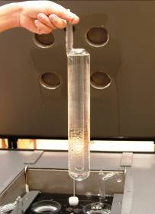
標準及校正實驗所內的水三相點容器
Triple Point of Water Cell in the Standards and Calibration Laboratory
 |  | 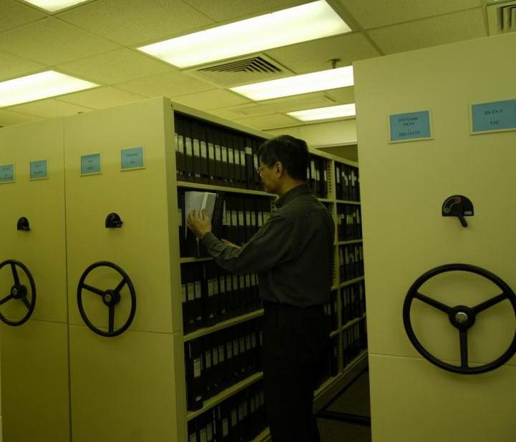
產品標準圖書館
Product Standards Library

日期及時間： 2007年10月11日 (星期四) 下午3時至4時
Date and Time : 11 October 2007 (Thursday) 15:00 – 16:00
地點： 香港灣仔告士打道7號入境事務大樓36樓創新科技署
Venue : Innovation and Technology Commission, 36/F, Immigration
Tower, 7 Gloucester Road, Wan Chai, Hong Kong.
入場費： 費用全免
Admission Fee : Free of charge
名額： 20 (先到先得)
Capacity : 20 (first come first served)
截止報名日期： 2007年10月2日（星期二）
Deadline for application : 2 October 2007 (Tuesday)

參觀標準及校正實驗所和產品標準圖書館
Visit to Standards and Calibration Laboratory &
Product Standards Library

報名表格 Registration Form

姓名 Name (*先生Mr /女士Ms)
*請刪去不適用Delete where appropriate |  |  | 姓 |  |  | 名
 |  |  | Surname |  |  | Other names
聯絡電話 Contact Telephone: |  |  |  | 傳真 Fax:
電郵 Email:
簽署 Signature: |  |  |  | 日期 Date:

請將此報名表格傳真至2824 1302或電郵至qadmin@itc.gov.hk 給我們。
Please return this registration form to us by fax 2824 1302 or email to qadmin@itc.gov.hk.

附註 Note：
(1) 將採取「先到先得」方式決定參加者名單。
Enrolment is on a first come first served basis.
(2) 成功申請者將於2007年10月5日或之前收到電郵或傳真通知有關的詳細安排。
Successful application will be notified by email or fax on or before 5 October 2007 about the detailed arrangement.
- 未能成功申請者，將不會獲個別通知。
Unsuccessful application will not be informed individually.
- 在此表格收集的個人資料，將只作是次參觀用途。
The personal information collected in this form will be used solely for this visit.
- 如有查詢，請致電2829 4877給我們。
For enquiries, please call us at 2829 4877.

